A000-Czech Republic-Předmostí-Figurine-Mammoth-Ivory-29,000-22,000 BP

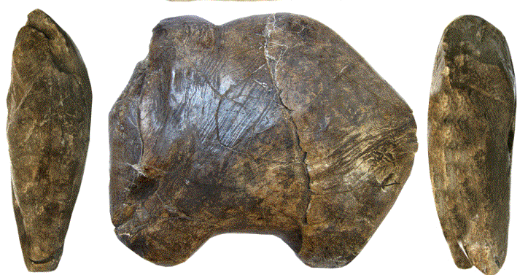

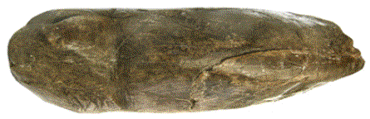 

Facies dorsalis

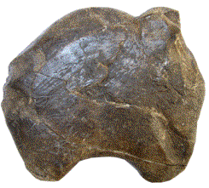

Figs. 1-6. Czech Republic-Předmostí-Figurine-Mammoth-Ivory-29,000-22,000 BP-

Replica

**Formal Label:** Czech Republic-Předmostí-Figurine-Mammoth- Ivory-29,000-22,000 BP-

Replica

**Display Description:** This mammoth figurine carved from mammoth ivory was excavated from Předmostí bei Přerov, a cluster of three Upper Paleolithic (Gravettian) sites on limestone outcrops dating to 29,000-22,000 BP, located in Moravia, Czech Republic. The figurine is interesting because it is not meant to be a realistic portrayal but rather an interpretation of the animal in the act of foraging the tundra with carefully distinguishable stylistic features that display the animal with frontal feet extended forward and head and trunk bent, providing an aspect of its behavior that suggests obliviousness to danger. . It is composed of a single globular volume perhaps indicative of a pregnant female. As such, this may have been used as a pedagogical device that was intended to teach inexperienced hunters to recognize the pose of a foraging, female, pregnant mammoth.

These hunters were indeed successful at hunting mammoths and other mammals, based on the fact that the hearths within their dwellings have yielded burned bone of over 1,000 mammoths, and added to these were bones of Pleistocene mammals including fox, horse, wolf, bear, wolverine, hare, and dog, and of this latter mammal some were considered possibly domesticated by their physical anatomy (Germonpre *et alii* 2012). Based on this assemblage of bone, the site was used for an extended period of time.

**Accession Number:** A000

**LC Classification:** GN772.22.C95

**Date or Time Horizon:** 26, 870 +/- 250

**Geographical Area:** Předmostí bei Přerov, Moravia, Czech Republic, a cluster of three Upper Paleolithic (Gravettian) sites on limestone outcrops.



Fig 7. Předmostí bei Přerov clay dune in which the sites were excavated, photograph by Přerov, archeological locality, Chromeček parcel, 1896. [PD-1923](https://commons.wikimedia.org/wiki/Template:PD-1923)

**Map, GPS coordinates:** 49.467000N, 17.437000E; 49° 27′ 56″ N, 17° 26′ 23″ E.

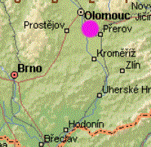 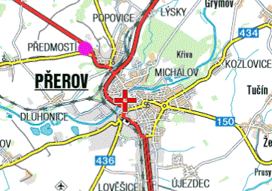

Figs. 8-9. Maps of Předmostí bei Přerov from http://www.biologus.eu/Predmosti%20%20%20UR%20Karte_soubory/image004.gif

**Cultural Affiliation:** Upper Paleolithic, Gravettian.

**Medium:** mammoth ivory.

**Dimensions: L 11.6 cm, H 10 cm, W 3.3** cm.

Condition: museum replica in resin.

Provenance: Moravian Museum in Brno, acc. no. 11671.

**Discussion:**

Accompanying these burned bones were bone tools, figurines and bone artifacts with engravings of animals. The graves that accompanied these sites were few—only about 20. Since these sites were occupied for an extended period it is unexplained why there were only 20 burials (primary, secondary and incomplete) and no red ocher, usually a sign of ritual internments, which led some early researchers to conclude that these burials were evidence of cannibalism a position that has been challenged more recently.

Excavations at Předmostí bei Přerov conducted between 1884 and 1930 were lost in World War II and the recent excavator, Jiří A. Svoboda, has attempted to collate these lost collections by comparing their recorded taphonomy with that of recent excavations (Svoboda 2007, 2008).

“The origin of Gravettian is seen as a more complex process than was thought before, involving an impact of industries with backed blades and bladelets from the eastern Mediterranean (Ahmarian, Lagaman, Dabba, beginning before 40 ky BP). After its establishment in Europe, the Danubian Gravettian is ordered into earlier Pavlovian stage (30-25 ky BP), concentrated in the Austrian-Moravian-South Polish corridor, and later Willendorf-Kostenkian stage (25-20 ky BP), widely dispersed over central and eastern Europe” (Svoboda 2007).

**References:**

Germonpré, Mietje, Martina Lázničková-Galetová, Mikhail V. Sablin. 2012. “Palaeolithic dog skulls at the Gravettian Předmostí site, the Czech Republic,” *Journal of Archaeological Science,* 39(1):184-202.

Svoboda, Jiří A. 2007. “The Gravettian on the Middle Danube,” *Paleobiology,* 19:203-220.

Svoboda, Jiří A. 2008. “The Upper Paleolithic burial area at Předmostí­: ritual and taphonomy,” *Journal of Human Evolution,* 54(1):15-33.

Velemínská, J., J. Brůžek, P. Velemínský, L. Bigoni, A. Šefčáková, [S. Katina](http://www.sciencedirect.com/science/article/pii/S0018442X07000583). 2008. “Variability of the Upper Palaeolithic skulls from Předmostí ­ near Prerov (Czech Republic): Craniometric comparison with recent human standards,” *HOMO - Journal of Comparative Human Biology,* 59(1):1-26.